MBSD Lab #3 A.Y. 2023/24

# Purposes

* Perform some parts of the Functional and Technical Safety Concept analysis, according to ISO26262, of a “one pedal controller” for a car.
* Implement some of the safety concepts in the Simulink model of the controller developed in Laboratory #2.
* Perform unit and integration tests on the implemented safety-related functionalities.

It is available an example of a Functional Safety Concept for the item Front Light Manager (FLM).

The deliverable, composed of

* the report (the following pages of this document)
* the Simulink models on where the safety concepts have been implemented
* all the needed files to replicate the software testing results

has to be provided as a .ZIP file up to **June 23rd at 23:59.** It shall also contain a brief report explaining the design of the controller using the following template.

It is sufficient that only one of the group members uploads it.

**Important hint:**

For the following analysis, consider as ASIL C all the safety goals related to unintended acceleration (those leading to an increase of the vehicle’s speed modulus) and as ASIL B the warnings to the driver and the unintended deceleration (those leading to a decrease of the vehicle’s speed modulus).

# Model-Based Software Design, A.Y. 2023/24

# Laboratory 3 Report

## Components of the working group (max 2 people)

* Matteo Gravagnone, s319634
* Danilo Guglielmi, s318083

Functional Safety Concept

One pedal

# Functional safety architecture

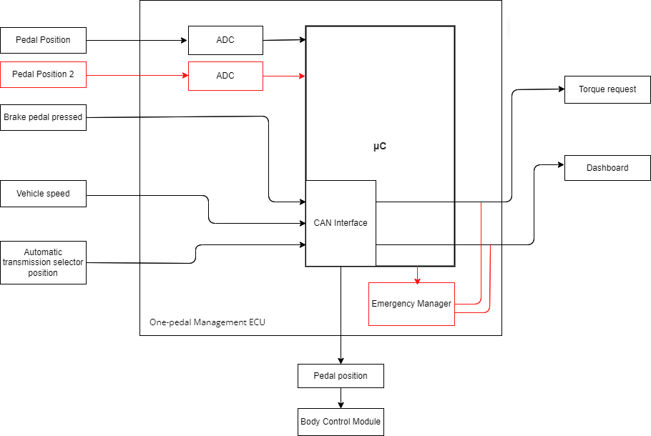

Figure 1 Functional safety architecture (from the safety concept)

# Attributes of the safety goals

*Fill in the attribute/parameters of the safety goal*

|  |  |  |  |  |  |
| --- | --- | --- | --- | --- | --- |
| **Safety goal** | **Attributes/Parameters of the safety goal** | | | | |
| Integrity (ASIL) | Safe state | Fault tolerance time | Warning concept | Degradation concept |
| SG1 | C | Switch to N | 100 ms | The driver must be notified on the dashboard | Motor is turned off |
| SG2 | B | Switch to N | 100 ms | The driver must be notified on the dashboard | Motor is turned off |
| SG3 | B | Warning of the malfunction | 100 ms | The driver must be notified on the dashboard | Warning system is deactivated |

# Functional (and technical) safety requirements and allocation

|  |  |  |  |  |  |
| --- | --- | --- | --- | --- | --- |
|  | | **Define functional safety requirements** | | **Allocation of requirements on systems and elements** | |
| **Safety requirements** | **Remark** | **If applicable, allocate the safety requirements to other Items / Systems** | **If applicable, allocate the safety requirements to equipment other technologies to minimize risk.**  **That could be e.g. hydraulic, mechanical equipment** |
| **Safety goals** | **The vehicle must not accelerate unintentionally** | SR1: If the pedal position interpreted is not valid (between 0 and 1), the torque request is set to 0. | No | No | Hydraulic braking system |
| SR2: The torque should be limited in the correct interval depending on the current state: if B between [-80, 80], if D between [0; 80], if R between [-40, 0], 0 if N or P. | No | No | Hydraulic braking system |
| **The vehicle must not decelerate unintentionally** | SR1: If the pedal position interpreted is not valid (between 0 and 1), the torque request is set to 0. | No | No | No |
| SR2: The torque should be limited in the correct interval depending on the current state: if B between [-80, 80], if D between [0; 80], if R between [-40, 0], 0 if N or P. | No | No | No |
| **The vehicle should be able to detect malfunctions in the warning system** | SR1: Monitor the functionality of the warning system periodically with specific diagnostic routines. | No | No | No |
| SR2: Notify the driver with a specific error message and activate a dashboard light if a warning malfunction is detected. | No | Warning lamp in the Cockpit-Display | No |

# ASIL preliminary architecture[1]

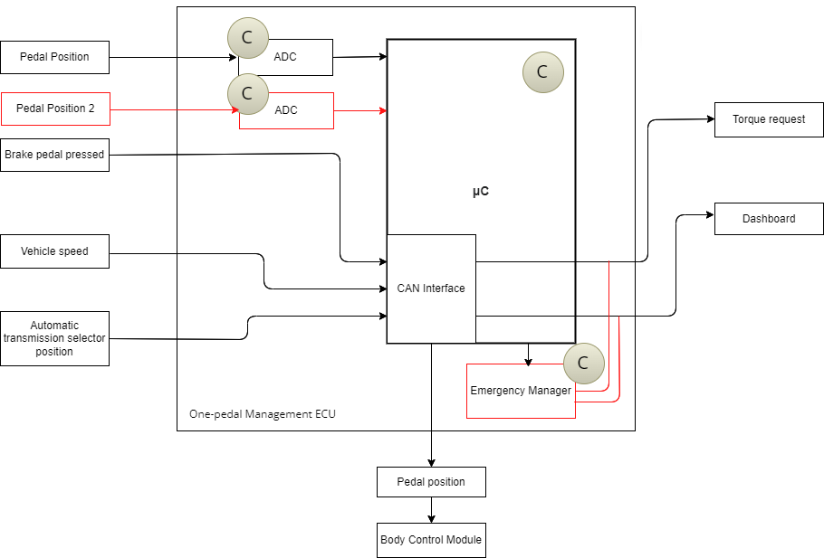

Figure 2 Preliminary architecture without ASIL decomposition

# Implementations[2]

## Functional redundancies

The system can have at least 2 circuitries that can read the pedal position at the same time.

The μC can be replaced, in case of failure, by a simpler circuit, called Emergency Manager, that warns the driver of the failure and sets the torque request to zero. In our implementation, the μC is responsible for warning and actions, and its failure is not managed.

## Implemented plausibility checks

* *BrakePedalPressed* is a boolean value so plausibility checks are not needed.
* *ThrottlePedalPosition* needs to be in the range [0; 1] so if the position is not valid, a warning flag is set. A secondary *ThrottlePedalPositionRedundancy* input is also checked in the same range, a warning flag is set. If the discrepancy between the two variables is larger than 0.1 (10% of the pedal travel), a warning flag is set. An overall *PedalWarningFlag* is set to true if at least one of the previous three flags is set.
* *AutomaticTransmissionSelectorState* is seen as an integer value between 0 and 4. If it is not in this range, a warning flag called *SelectorWarningFlag* is set.
* *TorqueRequest_Nm* is limited in the correct interval depending on the current AutomaticTransmissionState value: if B between [-80, 80], if D between [0; 80], if R between [-40, 0], 0 if N or P.
* If at least one between *PedalWarningFlag* and *SelectorWarningFlag* is set, the controller sets *Warning* to true,switches to N and sets the torque request to zero.

# Software testing

## Implemented unit tests

*Describe in English the test performed to verify the correct functionality of the safety mechanism implemented.*

In our model 4 different units, related to safety mechanisms, were tested.

For each of them, a test harness, with its own *.slx* file, was created through Simulink Test and modified with a set of proper test inputs for our coverage tests.

*Decision* was chosen as *Structural coverage level* in the coverage metrics settings of the harness in order to obtain values for branch and statement coverage.

* *controller_Harness_PedalPosition*: this harness is used to check the behavior of the mechanism related to the throttle pedal position, which implements the check about the range of both input pedal positions and the difference, in magnitude, between them, which shall not be larger than 0.1 in normal behavior.

* *controller_Harness_Selector*: this harness tests the mechanisms that checks the values of the AutomaticTransmissionStateSelector. The part of the harness related to the input has been modified in order to “force” invalid values of the input, otherwise Simulink would not allow them when requiring a cast to the enum TransmissionState (The subsystem which implements the safety mechanism therefore has not been modified in any way).

In addition, the logic has been made more elaborated in order to include a decision block (Switch).

* *controller_Harness_Torque*: this harness tests the mechanism that saturates the torque to the limit values according to the current transmission state. Therefore, it switches to different states and uses both correct and incorrect values of computed torque.

* *controller_Harness_Warning*: it is used to evaluate the behavior of the mechanism that, based on the flag which would be computed from the first two mechanisms, decides whether to switch to N and force zero torque or, otherwise, keeps the computed current transmission state and torque request.

Report generated through Simulink have been included in the provided files.

## Implemented integration tests

*Describe, in English, the scenarios tested at the integration level to verify the proper integration between the various units implementing the safety mechanisms.*

*controller_Harness*: this harness includes the overall controller and, in addition, also the connection to the plant which computes realistic values of the vehicle speed. A variety of inputs has been chosen to cover the considered problems, as the safety mechanisms shall work together.

The following image helps us tell why the decision does not reach 100% everywhere.

The StateFlow Chart, responsible for the computation of the TransmissionState and TorqueRequest, always produces values in the valid range and, as a consequence, the saturation blocks do not actually intervene.

Regarding the *AutomaticTransmissionSelectorState*, the model requires Enum: TransmissionState as a data type, therefore values not allowed in the enumeration cannot be selected.

To reach 100% decision everywhere, we would have to modify the model to have a “relaxed” input for the selector and to force incorrect values of torque request.

1. See document 02-iso26262.pdf, slides 89, 90, 91, 92, 93.
2. In the ISO26262 the implementations are based on a document called *Technical Safety Concept*, but for simplicity we move straight from the *Functional Safety Concept* to software implementations.

   A guideline for the implementation phase can be found in the document 02-iso26262.pdf from slide 81, in particular slide 86.